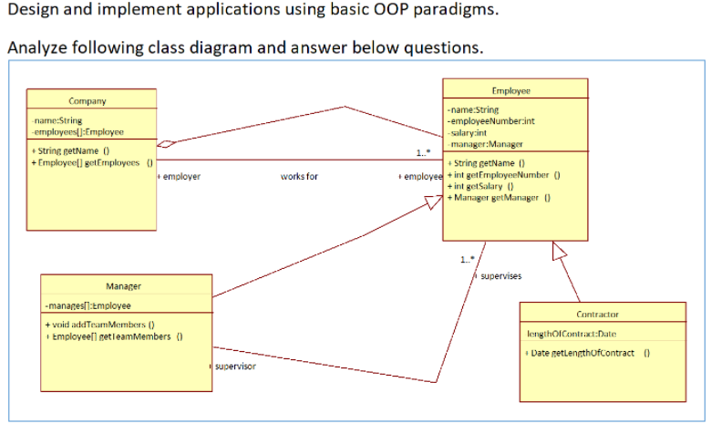

1. Identify the classes?

Class names in the above Class Diagram are:

->Company

->Employee

->Manager

->Contractor

1. Identify the relationships between each classes?

The relationship between the classes Company and Employee is a association i.e one or more than one employee works for a company. And the class Employee works for the class Company, so it is mentioned as aggregation in between them with the diamond pointed towards Company class.

The Manager class has generalization/Inheritance from the Employee class i.e Manager is also a employee and inherits the employee class. There is also a association relationship between the manager and employee classes i.e the manager is the supervisor and supervises one or more than one employee of the company.

The Contractor class has a generalization/Inheritance relationship with the employee class.

1. Identify the attributes and methods?

|  |  |  |
| --- | --- | --- |
| **CLASS** | **ATTRIBUTES** | **METHODS** |
| Company | Name  Employees | getName()  getEmployees() |
| Employee | Name  EmployeeNumber  Salary  Manager | getName()  employeeNumber()  getSalary()  getManager() |
| Manager | Manages | addTeamMembers()  getTeamMembers() |
| Contractor | LengthOfContract | getLengthOfContract() |